**Customer Churn Analysis**

**Problem Definition:**

Customer churn prediction is used in many businesses to evaluate a company’s loss rate. Customer churn occurs when a company’s customers stop doing business with that company. Businesses are very keen on measuring churn. keeping an existing customer is far less expensive than acquiring a new customer. New business involves working leads through a sales funnel, using marketing and sales budgets to gain additional customers. Existing customers will often have a higher volume of service consumption and can generate additional customer referrals. Predicting the churn rates accurately is important as it helps the business in better understanding future expected revenue. It can also help in identifying mistakes and improve in areas where there is a lack of customer satisfaction.

Customer retention can be achieved with good customer service and products. But the most effective way for a company to prevent attrition of customers is to truly know them. The vast volumes of data collected about customers can be used to build churn prediction models. Knowing who is most likely to defect means that a company can prioritize focused marketing efforts on that subset of their customer base.

Customer churn rate can be calculated by dividing no of customers lost in a given time interval by the total no of customers multiplied by 100. For example: If there are 200 customers in a company and it has lost 5 customers in a month then that month’s churn rate will be (5/200)*100 = 2.5%. So that month’s churn rate is 2.5% of that company.

Preventing customer churn is critically important to the telecommunications sector, as the barriers to entry for switching services are so low.

In this article, we will examine data from IBM Sample Data Sets with the aim of building and comparing several customer churn prediction models.

The link to find the .csv file is: <https://github.com/dsrscientist/DSData/blob/master/Telecom_customer_churn.csv>

**Project Name: - Telecom Customer Churn Analysis**

* Customer churn is when a company’s customers stop doing business with that company.
* Businesses are very keen on measuring churn because keeping an existing customer is far less expensive than acquiring a new customer.
* Existing customers will often have a higher volume of service consumption and can generate additional customer referrals.
* Customer retention can be achieved with good customer service and products. But the most effective way for a company to prevent attrition of customers is to truly know them.
* The vast volumes of data collected about customers can be used to build churn prediction models.
* Preventing customer churn is critically important to the telecommunications sector, as the barriers to entry for switching services are so low. You will examine customer data from IBM Sample Data Sets with the aim of building and comparing several customer churn prediction models.
* In This Dataset we have 21 columns and 7043 rows
* in which Customer Churn column is our target variable and other column is our input variable.
* the main of this project is to predict the Customer Churn (customer Attrition) for telecom Industry

**Step 1: Exploratory data analysis (EDA)**

* read & preview the dataset
* variable identification # looking the input data # what will be the output variable
* univariate analysis - tacking small variable and plot bar chart and finding histogram
* Bivariate analysis - tacking two column or two variable and looking the relationship between them, and also find correlation and covariance within two variable
* handling and removing null values- missing data
* Handling Categorical Variable
* finding and removing outliers

**Importing the data:**

We need to import all the relevant libraries:

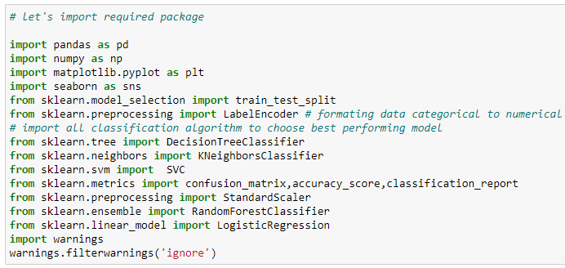

We will preview the dataset, shape, datatype

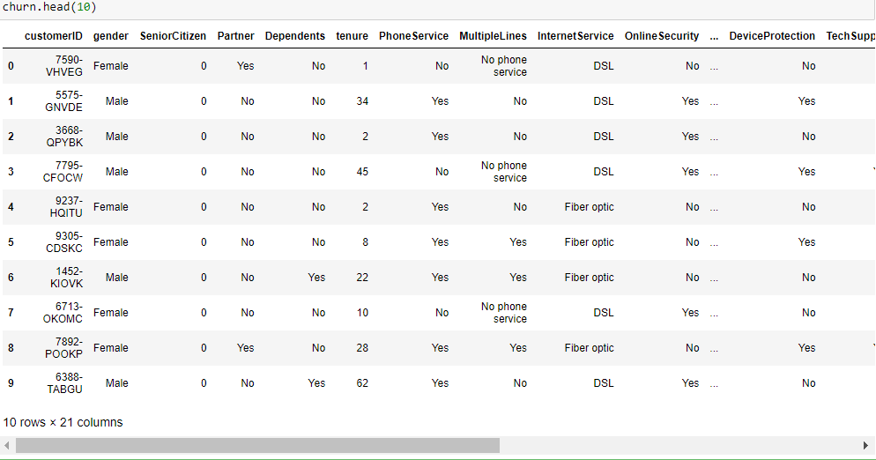

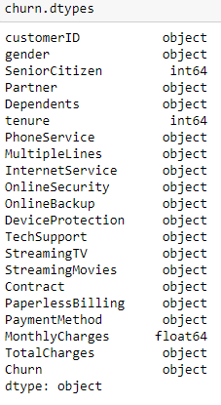

This data set contains both Independent and Dependent (target) variables.

Independent variable: They are also known as Input variables. These are the input for a process that is being analyzed.

Dependent variable: They are also known as Output or Target variables. They are dependent on Independent variables for their outcome

After importing the dataset, display a sample of data. The variables in the dataset are as follows:

* customerID
* gender
* SeniorCitizen
* PartnerDependents
* Tenure
* PhoneService
* MultipleLines
* InternetService
* OnlineSecurity
* OnlineBackup
* DeviceProtection
* TechSupport
* StreamingTV
* StreamingMovies
* Contract
* PaperlessBilling
* PaymentMethod
* MonthlyCharges
* TotalCharges
* Churn

**Data Analysis (EDA):**

**Now we need to understand the dataset by performing Exploratory Data Analysis.**

Let’s check the shape of the data set:



* We can see that there are 7043 rows and 21 columns in the dataset.
* We cannot have null values in the data as this will affect the data and eventually, the predicted result will not be correct. Therefore we must check for any null values in the dataset.

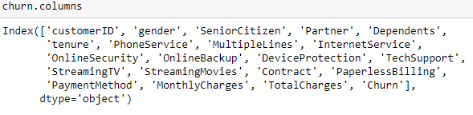

Checking for null values in the data set:

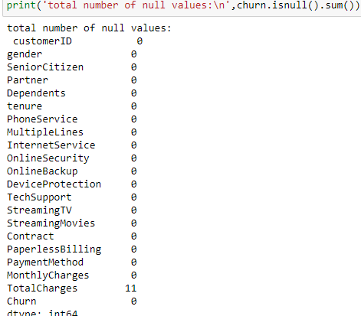

Let’s check is data is distributed normally or not by plotting histogram

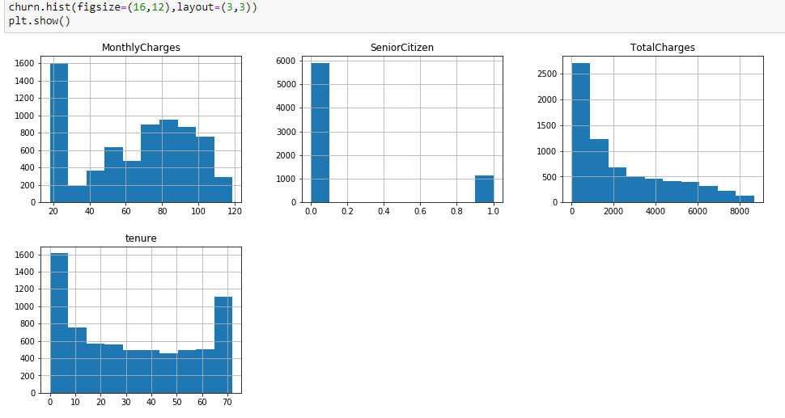

let's check skewed columns with the help of skew()

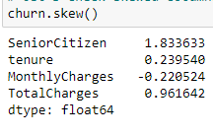

as per data only Total Charges is positively skewed

Checking outliners

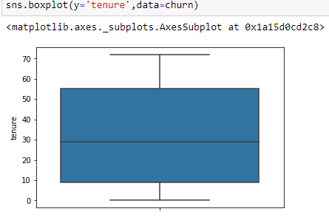 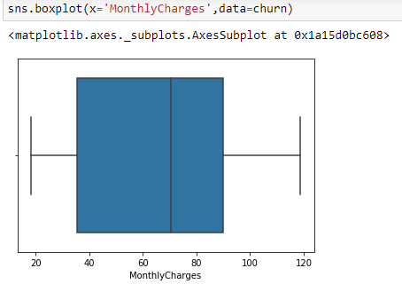 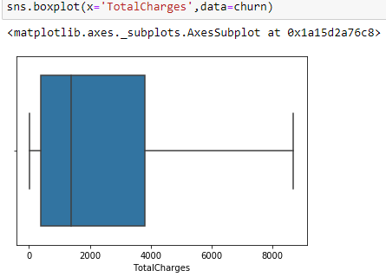

# Key observation: -

* the histogram of tenure column seems like normal distribution
* the histogram Total Charge column show average Total charged taken by customer is 2200
* from the histogram we say that customer paying average monthly charged 70 Rs.
* unique id is above 7000 in the customer id column so it is need to drop.

**Data Visualization and EDA Concluding Remarks:**

In the given data, ‘churn’ feature is the Target feature or variable. The unique values of this feature are only 2 i.e Yes and No, which means it has only two classes. So, as there are only two unique values this is a ‘Classification Problem.’

Let’s know how the columns data distributed in the dataset i.e. univariate data analysis by graphical representation.

Firstly, we will be plotting Churn feature with help of countplot to understand whether it's balanced or imbalanced data.

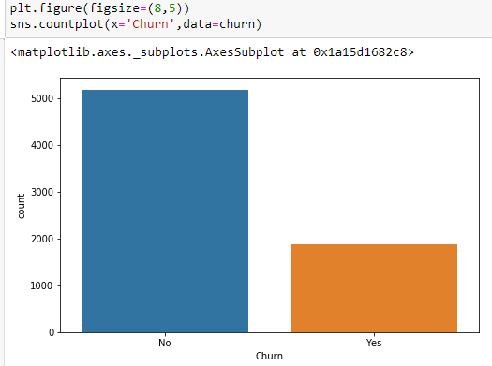 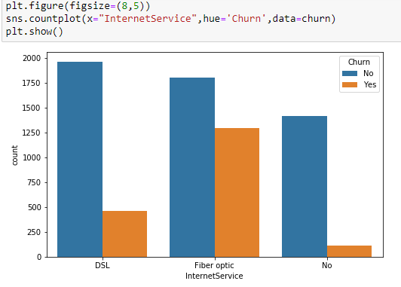

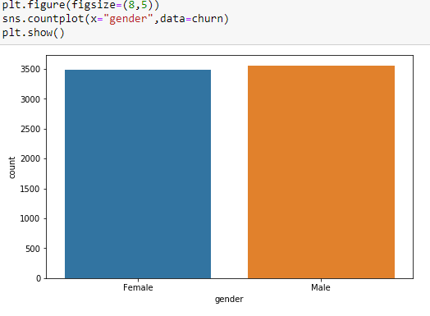 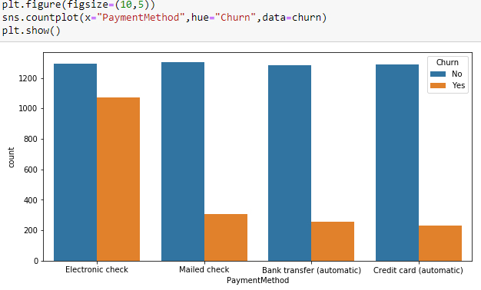

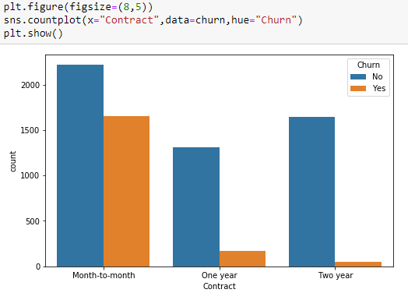 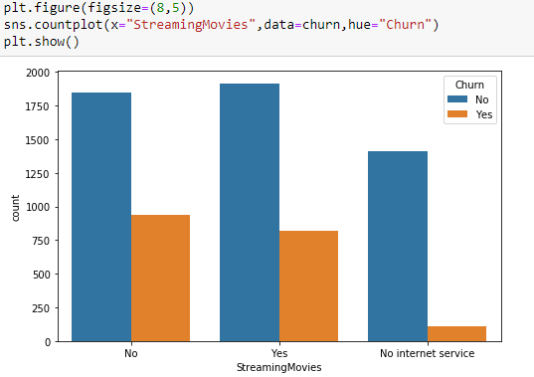

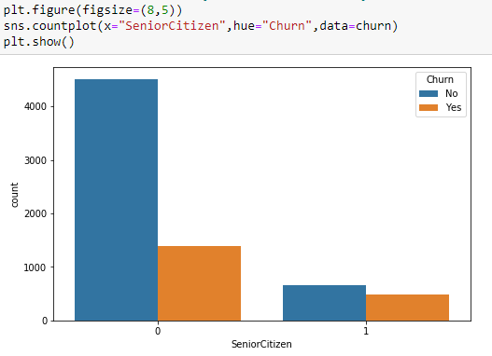 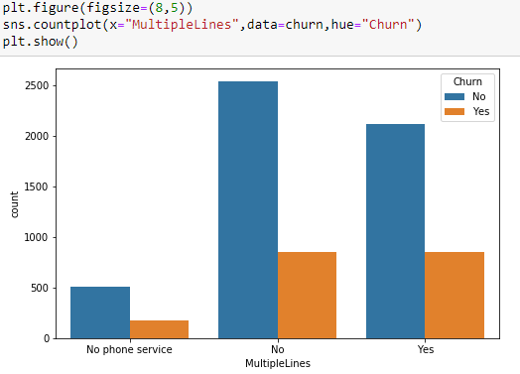

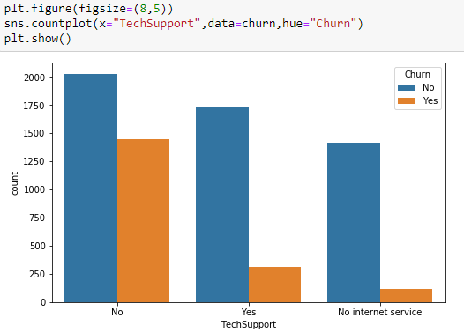 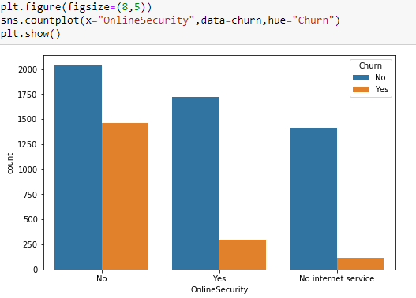

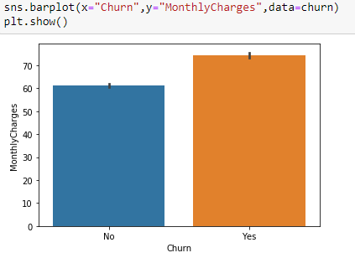 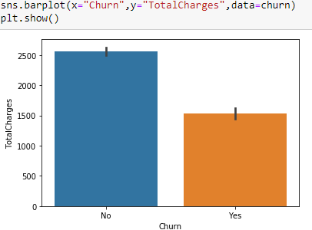

This means that 5174 customers were not churned (retained) and 1869 customers were churned.

We can even get the Churn rate from this by dividing no of customers lost in a given time interval by the total no of customers multiplied by 100.

In this case, about 73.46% are retained and the churn rate is 26.53%.

As shown above, we can see that there’s a very slight difference between the two genders, which says that gender doesn’t play a role in customer churn.

We can see that the churn is lesser if the customer is a senior citizen as they might have to start searching for a new company which would again take a lot of time and thus think it would be better to stick to the present company.

We can see that most customers that churned had the Fiberoptic internet service. Maybe the company Should have only DSL internet service.

We can see that most customers that churned are having electronic check payment method. Maybe the company Should avoid this.

We can see customers who have churned are mostly having contract of Month to Month were as customer having contract for two years they are mostly not churned.

**Pre-processing Pipeline:**

The data set has variables in both object type and numerical type (int and float)

Therefore, we have to pre-process the data to move forward.

All the float type or int type variables should be converted into the same scale since the range of values of raw data varies widely, in some machine learning algorithms, objective functions do not work correctly without normalization.

We can see that majority of variables are object-type. These variables contain string data that cannot be passed into the machine learning model as it won’t be able to recognize string data type. It only recognizes numerical data.

Therefore, we need to convert the string data into numerical data. This can be done by manually encoding or by using an encoder such Label Encoder, one-hot encoder etc. For example: The target variable churn consists of only two unique values, Yes & No. after encoding this will get converted to 0 and 1. Similarly, if there are three unique values then it will be converted to 0,1, and 2.

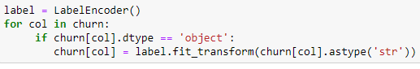

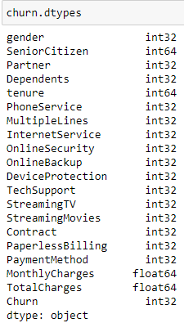

**Correlation between ‘Churn' and 'Independent features'**

Now we can check the correlation between all the variables. (Note: correlation of all independent variables can be only done after encoding as correlation does not consider string values)

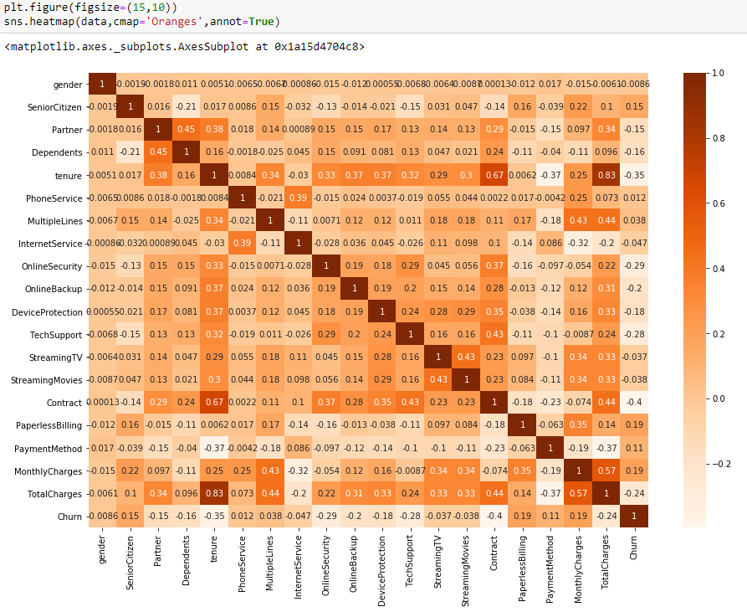

We can see that correlation between independent variables is low(i.e. <0.7). We are good to go.

From the figure below we can see the important features in descending order from top to bottom.

We can see that MonthlyCharger and PaperlessBilling are the top two important features for the taget variable ‘churn’

Now the pre-processing is completed. We now have to move to data modelling and prediction

**Building Machine Learning Models:**

Here the target variable is ‘Churn’ and the rest of them are independent variables.

We have to now split the independent and target variables into training and testing datasets as shown below.



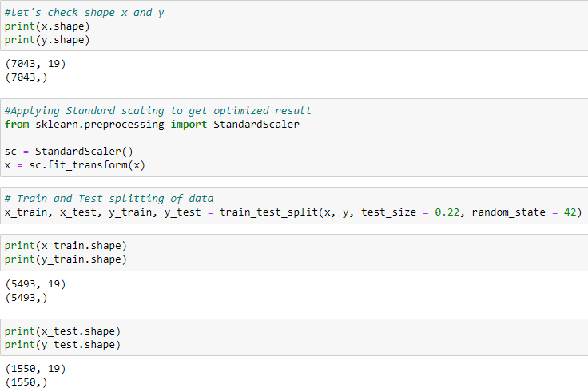

# Our training and testing data are ready now to perform machine learning algorithm

# Telecom Customer Churn prediction is a classification problem, so we can use Multiple classification algorithm with hyperparameter tune.

* First, we use Logistic regression model because the target variable holds binary classification (0 and 1) to check accuracy score level.
* we also used different classification model to check and compare whether we get high accuracy score or not, this exercise help us to select best model.

We will use a machine-learning algorithm to learn from the training set and use the model to predict the testing set and compare it with the predicted data with the target testing set to know how close the values. If the error between the predicted and target testing data is less that means the accuracy of the model is high and we can use this model to predict the result of similar datasets.

**Cross Validation:**

K-Folds cross validation is one method that attempts to maximize the use of the available data for training and then testing a model. It is particularly useful for assessing model performance. "Cross_val_score" splits the data into say 5 folds, then for each fold, it fits the data on 4 folds and scores the 5th fold. Then it gives you the 5 scores from which you can calculate a mean and variance for the score. It is useful to tune parameters and to get an estimate of the score.

# AUC ROC CURVE:

# AUC: Area Under the curve;   ROC: Receiver Operator Characteristic

# The greater the ROC score the better is the model. If ROC=1, then it perfectly fits.

# If the maximum of the area falls under True positive then the model is doing good.

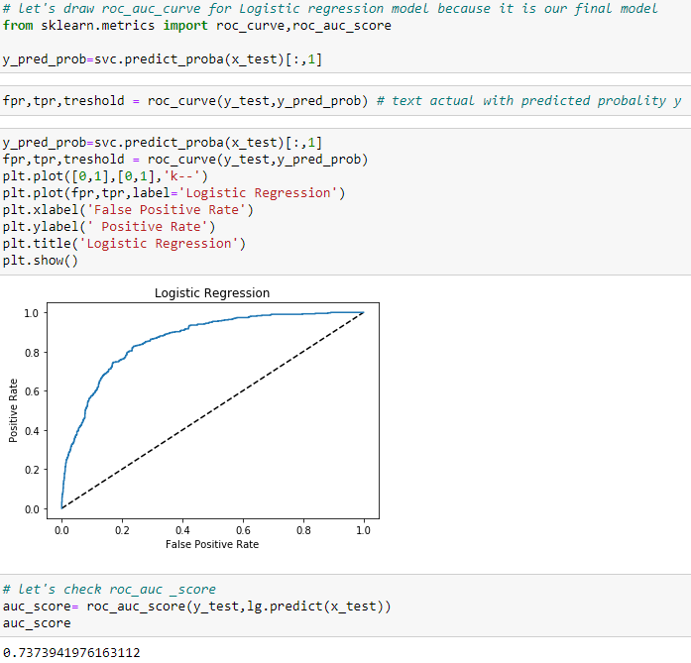

We can see that the ROC Score is 0.73 and the area under the curve falls under True Positive Rate, Therefore, we can conclude that the model is performing well and we need to save the model in .obj file for future use.

**Concluding Remarks:**

From the above results of the data modelling and prediction we can see that the Logistic regression Model is performing well as the accuracy score, cross val score and Roc score are good also the maximum of the area under the curve fall under true positive rate. Therefore, we can save the model as .obj file so that it can be used to predict the result of the different data sets.

In this kind of problems Pre-processing and data-cleaning is the most important thing. We need to handle both the categorical and numerical data properly and also need to check by building different ML model on the same dataset. We need to check the accuracy and cross val score of each model and chose the one which has the best of the same and also which has the least difference between them (i.e cross_val_score and accuracy).

We could see that there is no impact of gender on the churn rate. Also, the company must avoid using phone service, Paperless billings, electronic check payment method.

By using this model many companies can find their mistakes and improve which will lead to financial gain.